-- 1. Finding 5 oldest users
- SELECT * FROM users
- ORDER BY created_at
- LIMIT 5;

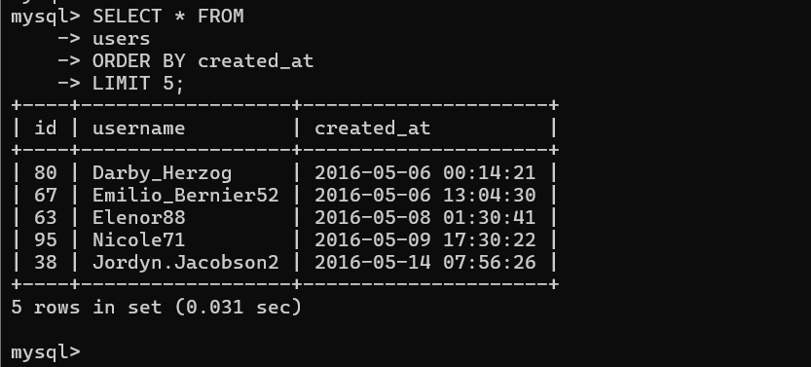

- - 2. Most popular Registration Date

- SELECT
- DAYNAME(created_at) AS day,
- COUNT(*) AS total
- FROM users
- GROUP BY day
- ORDER BY total DESC
- LIMIT 2;

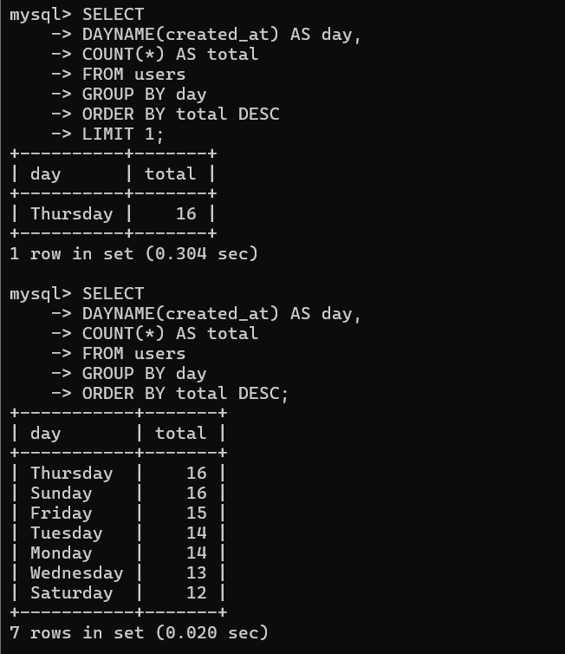

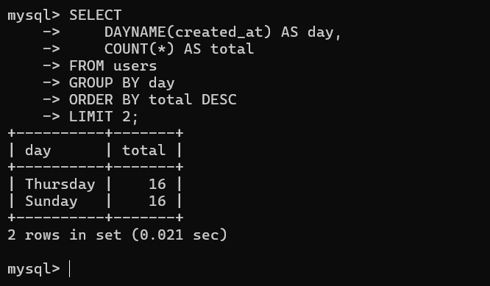

— 3. Identify Inactive Users (users with no photos)

- SELECT username
- FROM users
- LEFT JOIN photos
- ON users.id = photos.user_id
- WHERE photos.id IS NULL;

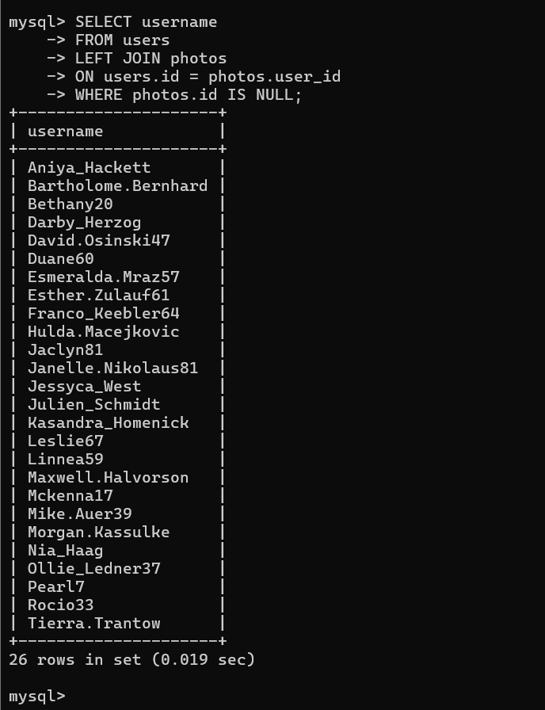

—4 Identify most popular photo (and user who created it)

- SELECT
- username,
- photos.id,
- photos.image_url,
- COUNT(*) AS total
- FROM photos
- INNER JOIN likes
- ON likes.photo_id = photos.id
- INNER JOIN users
- ON photos.user_id = users.id
- GROUP BY photos.id
- ORDER BY total DESC
- LIMIT 1;

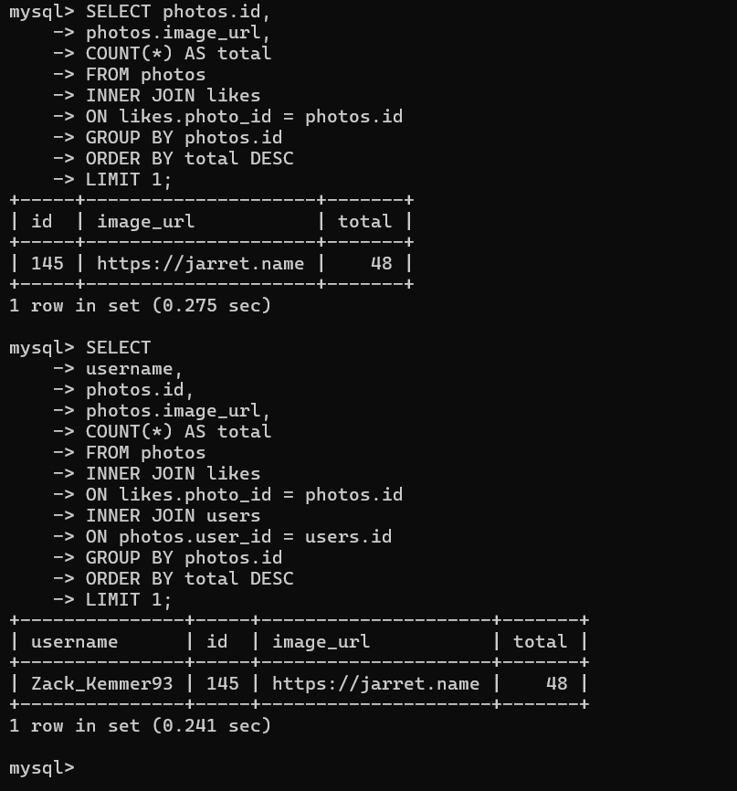

- - 5 calculate average number of photos per user

- SELECT (SELECT Count(*) FROM photos) /
- (SELECT Count(*) FROM users) AS avg;

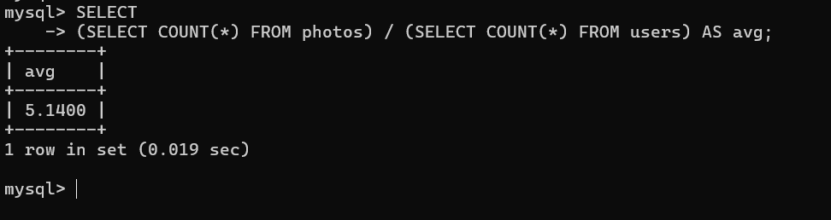

— - 6 five most popular hashtag

- SELECT tags.tag_name,
- Count(*) AS total
- FROM photo_tags
- JOIN tags
- ON photo_tags.tag_id = tags.id
- GROUP BY tags.id
- ORDER BY total DESC
- LIMIT 5;

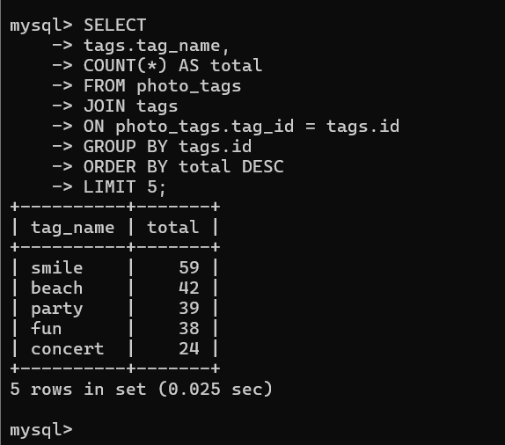

- - 7 Finding Bots - users who have liked every single photo

- SELECT username,
- Count(*) AS num_likes
- FROM users
- INNER JOIN likes
- ON users.id = likes.user_id
- GROUP BY likes.user_id
- HAVING num_likes = (SELECT Count(*)
- FROM photos);

